Acupuncture & Chinese Herb Clinic
15710 NE 24th St. Suite E – Bellevue, WA 98008 – (425) 456-8880
Health History Questionnaire
Name: |  |  |  |  | Today's Date:
Address: |  |  |  |  | Phone (Home):
City: |  |  | State: |  | Phone (Work):
Zip: |  |  |  |  | Phone (Cellular):
Age: |  | Sex: |  |  | Weight: |  | Height:
Marital Status: |  |  |  |  | Occupation:
Place of Birth: |  |  |  |  | Date of Birth:
Family Physician: |  |  |  |  | SSN:
In Emergency Notify: |  |  |  |  | Phone Number:
Referred By: |  |  |  |  | Your Email:
Insurance Company: |  |  |  |  | Policy Number:
Have you been treated by acupuncture or Oriental medicine before?

Assignment and Release
I, the undersigned certify that I (or my dependent) have insurance coverage with:__________________
and assign directly to Acupuncture & Chinese Herb Clinic all insurance benefits, if any, otherwise payable to me for service rendered. I understand that I am financially responsible for all charges whether or not paid by insurance. I hereby authorize the doctor to release all information necessary to secure the payment of benefits. I authorize the use of this signature on all insurance submissions.

Responsible Party Signature: ___________________ Relationship: ___________ Date: ____________

Main problem(s) you would like us to help you with: _______________________________________ _________________________________________________________________________________
How long ago did this problem begin (be specific)? _______________________________________
_________________________________________________________________________________
To what extent does this problem interfere with your daily activities (work, sleep, sex)? ____________
_________________________________________________________________________________
Have you been given a diagnosis for this problem? If so, what? ________________________________
_________________________________________________________________________________
What kinds of treatment have you tried? __________________________________________________
_________________________________________________________________________________
Past medical history (please include dates): ______________________________________________
_________________________________________________________________________________
Significant Illnesses: Cancer Diabetes Hepatitis High Blood Pressure Seizures
Heart Disease Rheumatic Fever Thyroid Disease Venereal Diseases Other
__________________________________________________________________________________________________________________________________________________________________
Surgeries: ________________________________________________________________________ _________________________________________________________________________________
_________________________________________________________________________________
Significant Trauma (auto accidents, falls, etc.): ___________________________________________
_________________________________________________________________________________
_________________________________________________________________________________
_________________________________________________________________________________
Birth History: (prolonged labor, forceps delivery, etc.): _____________________________________
__________________________________________________________________________________
Allergies (drugs, chemicals, foods): _____________________________________________________
__________________________________________________________________________________
Family Medical History: Diabetes Cancer High Blood Pressure Heart Disease
Strokes Seizures Asthma Allergies Other
____________________________________________________________________________________________________________________________________________________________________
Medicines taken within the last two months (vitamins, drugs, herbs, etc.):
____________________________________________________________________________________________________________________________________________________________________
Indicate painful or distressed areas:
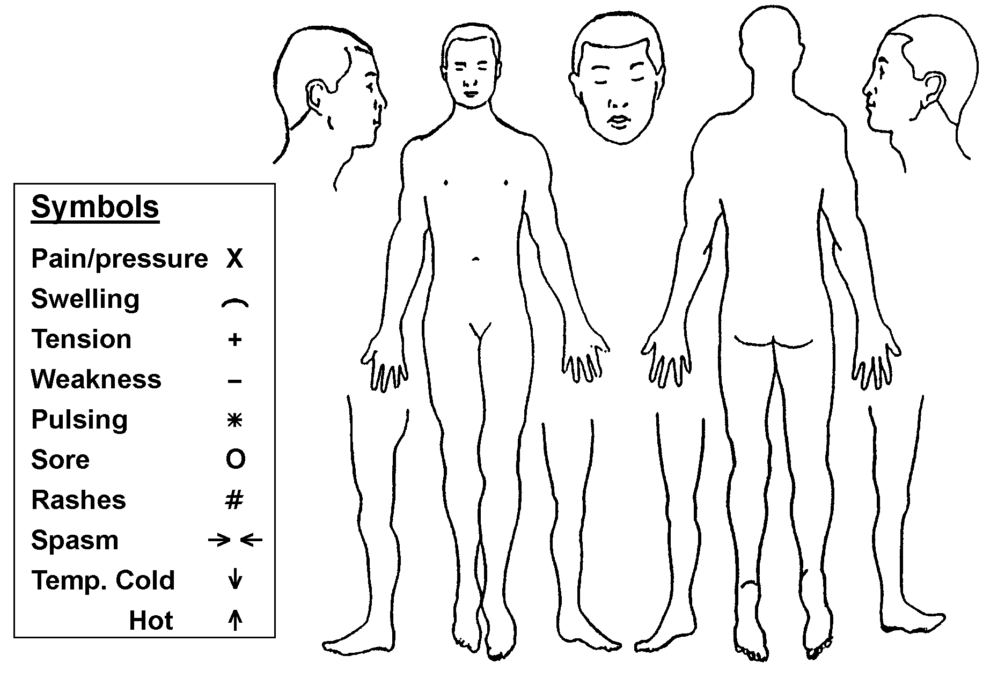
Occupation: ___________ Occupational stress (chemical, physical, psychological, etc.):
__________________________________________________________________________________
Do you have a regular exercise program? ______ Please describe: ______________________________
__________________________________________________________________________________
Have you ever been on a restricted diet? _______ What kind? __________________________________
Please describe your average daily diet:
Morning Afternoon Evening
____________________________________________________________________________________________________________________________________________________________________
__________________________________________________________________________________
Do you smoke? ______
What is the amount of cigarettes that you smoke in a day? __________________
How much coffee, tea, or cola do you drink per week? __________________________________________________________________________________
How much alcohol do you drink per week?
__________________________________________________________________________________
Please describe any use of drugs for non-medical purposes
__________________________________________________________________________________

Please check if you have had (in the last three months):
General
[] Poor Appetite [] Poor Sleeping [] Fatigue
[] Fevers [] Chills [] Night Sweats
[] Sweat Easily [] Tremors [] Cravings
[] Localized Weakness [] Poor Balance [] Change in Appetite
[] Bleed or Bruise Easily [] Weight Loss [] Weight Gain
[] Peculiar Tastes or Smells
[] Strong Thirst (cold or hot drinks)
[] Sudden Energy Drop (What time of day)?

Skin and Hair
[] Rashes [] Ulcerations [] Hives
[] Itching [] Eczema [] Pimples
[] Dandruff [] Loss of Hair [] Recent moles
[] Change in hair or skin texture
Any hair or skin problems?

Head, Eyes, Ears, Nose, and Throat
[] Dizziness [] Concussions [] Migraines
[] Glasses [] Eye Strain [] Eye Pain
[] Poor Vision [] Night Blindness [] Color Blindness
[] Cataracts [] Blurry Vision [] Earaches
[] Ringing in Ears [] Poor Hearing [] Spots in Front of Eyes
[] Sinus Problems [] Nose Bleeds [] Recurrent Sore Throats
[] Grinding Teeth [] Facial Pain [] Sores on Lips or Tongue
[] Teeth Problems [] Jaw clicks
Headaches (Where and when?)
Any other head or neck problems?

Cardiovascular
[] High Blood Pressure [] Low Blood Pressure [] Chest Pain
[] Irregular Heartbeat [] Dizziness [] Fainting
[] Cold Hands or Feet [] Swelling of Hands [] Swelling of Feet
[] Blood Clots [] Phlebitis [] Difficulty in Breathing
Any other heart or blood vessel problems?

Respiratory
[] Cough [] Coughing Blood [] Asthma
[] Bronchitis [] Pneumonia [] Pain With a Deep Breath
[] Difficulty in Breathing When Lying Down
[] Production of Phlegm (What color?)
Any other lung problems?

Gastrointestinal
[] Nausea [] Vomiting [] Diarrhea
[] Constipation [] Gas [] Belching
[] Black Stools [] Blood in Stools [] Indigestion
[] Bad Breath [] Rectal Pain [] Hemorrhoids
[] Abdominal Pain or Cramps
[] Chronic Laxative Use
Any other problems with your stomach or intestines?

Genito-Urinary
[] Pain When Urinating [] Frequent Urination [] Blood in Urine
[] Urgency to Urinate [] Unable to Hold Urine [] Kidney Stones
[] Decrease in Flow [] Impotency [] Sores on Genitals
Do you wake up to urinate? How often?
Any particular color of your urine?
Any other problems with your genital or urinary system?

Pregnancy and Gynecology
__ Number of Pregnancies __ Number of Births __ Premature Births
__ Miscarriages __ Abortions __ Age at First Menses
__ Period Between Menses __ Duration __ First Date of Last Menses
[] Unusual Character (Heavy or Light) [] Irregular periods
[] Painful Periods [] Clots [] Last PAP
[] Vaginal Discharge [] Vaginal Sores [] Breast Lumps
[] Changes in Body/Psyche Prior to Menstruation
Do you use birth control? What type and for how long?

Musculoskeletal
[] Neck Pain [] Muscle Pains [] Knee Pain
[] Back Pain [] Muscle Weakness [] Foot/Ankle Pains
[] Hand/Wrist Pains [] Shoulder Pain [] Hip Pain
Any other joint or bone problems?

Neuropsychological
[] Seizures [] Dizziness [] Loss of Balance
[] Areas of Numbness [] Lack of Coordination [] Poor Memory
[] Concussion [] Depression [] Anxiety
[] Bad Temper [] Easily Susceptible to Stress
Have you ever been treated for emotional problems?
Have you ever considered or attempted suicide?
Any other neurological or psychological problems?

Comments
Please tell us of any other problems you would like to discuss:
_________________________________________________________________________________________________
__________________________________________________________________________________________________________________________________________________________________________________________________

Acupuncture & Chinese Herb Clinic
15710 NE 24th St. Suite E – Bellevue, WA 98008 – (425) 456-8880
Informed Consent For Treatment

I, ______________________________, hereby authorize the private practitioners of Acupuncture & Chinese Herb Clinic to perform the following specific procedures as necessary to facilitate my diagnosis and treatment:

Acupuncture: insertion of special disposable needles through the skin into underlying tissues at specific points on the surface of the body. I understand there may be possible bruising, achiness, and bleeding as a result of acupuncture.

Cupping: a technique used to relieve symptoms in which cups made of glass or other materials are placed on the skin with a vacuum created by heat or other device. Cupping may cause bruising or blisters.

Heating Lamp or Pad: produces heat on the acupoints and meridians.

Electrical Acupuncture: use of electrical device to produce electrical stimulation on the acupuncture needles.

Herbs: may be given in the form of pills, powders, tinctures, pastes, or plasters. Herbal formulas may include shell, mineral, and animal materials.

Moxa: indirect burning on an acupoint using stick, string, or ball moxa to relieve symptoms.

Dietary Advice: based on traditional Chinese Medical Theory.

I recognize the potential risks and benefits of these procedures as described below:
Potential Risks: bruising, discomfort, pain, infection, or blistering at the site of the procedure; temporary discoloration of the skin; nausea, loose bowel movements, abdominal cramping; and aggravation of the symptoms following the acupuncture treatment.

Potential Benefits: drugless relief of present symptoms and improved balance of bodily energies, which may lead to prevention or elimination of the present problem and the strengthening of the constitution.

Notice to Pregnant Women: We do not use labor stimulating acupuncture points unless the treatment is specifically for the induction of labor. A treatment intended to induce labor requires a letter from the primary care provider authorizing or recommending such a treatment. All female patients must alert the doctor if they know or suspect that they are pregnant.

With this knowledge, I voluntarily consent to the above procedures, realizing that no guarantees have been given to me by Acupuncture & Chinese Herb Clinic or any of its personnel regarding cure or improvement of my condition. I understand that I am free to withdraw my consent and to discontinue participation in these procedures at any time.

I understand that Acupuncture & Chinese Herb Clinic may have a precept student for observation only. I understand that a record will be kept of my health services provided to me. This record will be kept confidential and will not be released to others unless so directed by myself or my representative of if it is required by law. I understand that I may look at my medical record at any time and can request a copy of it by paying the appropriate fee. I understand that my medical record will be kept for a minimum of three years, but no more than eight years after the date of my last treatment.

A full appointment charge will be charged for all subsequent no shows. Please let us know if you are unable to make your future appointments. Please give us at least 24 hours notice if you need to cancel.

I have read and understood the Acupuncture & Chinese Herb Clinic’s HIPAA Privacy Policies (which can be read at http://www.DrAmyChen.com/hipaa) or which a copy can be requested in person at our office.

________________ _________________________________________________ Date Signature of Patient, Patient Representative, or Guardian

